**Chapter 32: Particle Physics**

***Please remember to photocopy 4 pages onto one sheet by going A3→A4 and using back to back on the photocopier.***

**Cockroft and Walton shared the Nobel Prize for their work on splitting the atom*.**

**Operation**

1. Protons are produced and released at the top.
2. The protons get accelerated across a potential difference of 800 kVolt.
3. The protons collide with a lithium nucleus, and as a result two alpha particles are produced.
4. The alpha particles move off in opposite directions at high speed.
5. They then collide with a zinc sulphide screen, where they cause a flash and get detected by microscopes.

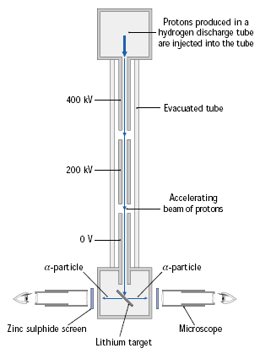

** +  →  + K.E.**

**1 MeV 17.3 MeV**

**Left Hand Side:**

The total mass/energy in consists of the proton plus lithium (plus kinetic energy of the proton of 1 MeV).

**Right Hand Side:**

The total energy out consists of the two alpha particles, (plus kinetic energy of the alpha particles of 17.3 MeV).

Using *E = mc2*, the scientists could explain the fact that there was more kinetic energy after than there was before: some of the mass had disappeared! The scientists were able to establish both the masses and the kinetic energies of all the particles and so could verify Einstein’s equation.

But it gets better – there are actually the same number of protons and neutrons on both sides. So how can there be more mass on one side than the other?? *“curiouser and curiouser*”, cried Alice . . .

**Why was this experiment significant?**

1. First *artificial* splitting of the nucleus.
2. First transmutation using artificially accelerated particles.
3. First verification of Einstein’s E = mc2.
4. First Particle Accelerator

**Converting other forms of energy into mass: Modern particle accelerators**

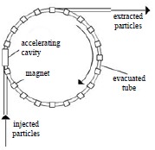

Nowadays the particle accelerators are much more powerful, and one of the more common experiments is to whack two protons off of each other.

To do this they are sent in opposite directions around a circular particle accelerator (e.g. in CERN).

The kinetic energy gets transformed into new and exotic particles.

**+ + kinetic energy = + + additional particles (+ kinetic energy)**

The larger the kinetic energy of the protons before collision, the greater will be the mass and variety of new particles produced

These particles were all new to science and became known as *the particle zoo\**.

**Anti-matter\***

Anti-matter has the same mass as ordinary matter but opposite charge.

Each particle has its own anti-particle. So for example the anti-electron (known as a positron) has the same mass as an electron but has a positive charge.

The **English physicist Paul Dirac** predicted anti-matter mathematically before it was detected experimentally.  
Clever boy.By the way, did you know that bananas produce antimatter about 15 times a day?

**Pair Production\***

Pair production involves the production of a particle and its antiparticle from a gamma ray photon.

**gamma ray photon (γ) → e- + e+ + K.E.**

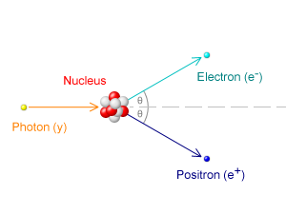**The energy associated with a gamma ray photon is given by *E = hf***

where *f* is the frequency of the wave and *h* is a constant known as*Planck’s constant* – it’s value is 6.626 × 10-34 J s and is available in the log tables.

Note:

1. **Conservation of Charge**

Net charge before and after is zero.

1. **Conservation of Momentum**\*

The gamma ray photon does have momentum! So for momentum to be conserved, there must be momentum afterward, therefore the two new particles cannot move off in opposite directions.

1. **K.E.** represents the kinetic energy of the electron and positron as they move off.

Pair production can only occur if the photon has an energy exceeding twice the rest mass of the electron.

The same applies for the generation of other higher energy leptons such as the muon and tau.

Why do we need the neutron?*

**Pair Annihilation**

An [electron](http://en.wikipedia.org/wiki/Electron) and a [positron](http://en.wikipedia.org/wiki/Positron) collide to produce two gamma ray photons

Note:

1. **Conservation of Charge**

Net charge before and after is zero.

1. **Conservation of Momentum**

For momentum to be conserved you must note that the electron and positron are either moving directly towards each other beforehand or are at rest and so have no (net) momentum.

Therefore in order for there to be no (net) momentum after, the two photons produced must fly off in opposite directions. ***You must use the phrase ‘gamma-ray photons’, and not just ‘photons’; the logic being that ‘gamma-ray’ implies a very high level of energy!***

**The neutrino\***

The neutrino was first postulated by the Austrian physicist Wolfgang Pauli (of Pauli’s Exclusion Principle), to account for the apparent discrepancy between the momentum before and after beta decay (remember this happens when a neutron splits into a proton and an electron). The term neutrino was itself coined by the Italian physicist Enrico Fermi.

The neutrino is extremely small, has *almost* no mass, and has zero charge (the term itself means ‘little neutral one’).

**Quarks**

It turns out that many particles which we thought to be fundamental are actually made up of more fundamental particles, called quarks.

There are six types of quark (see also page 49 of the log tables)

|  |  |  |
| --- | --- | --- |
| **Name of Quark** | Symbol | Charge |
| Up | u | + 2/3 e |
| Down | d | - 1/3 e |
| Strange | s | - 1/3 e |
| Charmed | c | + 2/3 e |
| Bottom | b | - 1/3 e |
| Top | t | + 2/3 e |

Where *e* is the charge of one electron, e.g. the Up quark has a charge of two thirds the charge of an electron.

Only the charges of the first three need to be known (and these are available in the log-tables).

So what’s different about the Up, Charmed and Top particles if they all have the same charge?

Answer: Mass. The Up has the smallest mass and the Top the greatest (which is why it took the longest time to detect). Same goes for Down, Strange and Bottom.

**Murray Gell-Mann\***

The term quark was given to these particles by the American physicist Murray Gell-Mann who first predicted their existence in 1964 and won a Nobel Prize for his work in Particle Physics. He found the word in a book by James Joyce, called *Finnegans Wake*.

**Anti-quarks**

**An anti-quark has the same mass as its quark counterpart, but opposite charge.**

e.g. an anti-up has a charge of – 2/3 e.

If a particle is composed of three quarks it is called a baryon and if it is composed of two quarks it is called a meson (actually the quark will be composed of a quark and an antiquark).

|  |  |  |  |
| --- | --- | --- | --- |
| **Particles made from quarks/antiquarks** | | | **Classification** |
| **Example** | **Composition** | **Charge** |  |
| Proton | uud | +1 (+2/3, +2/3, -1/3) | Baryon |
| Neutron | udd | 0 (+2/3, -1/3, -1/3) | Baryon |
|  |  |  |  |
| Pion | ud* | +1 (+2/3, +1/3) | Meson |

**Fundamental forces of nature**

Happily (hah!) we can categorise all particles on the basis of the quark composition and the forces which they are subject to.

It turns out that there are actually only four fundamental forces in nature. They are (in order of decreasing strength):

1. Strong nuclear force
2. Electro-magnetic force
3. Weak nuclear force
4. Gravitationalforce

|  |  |  |
| --- | --- | --- |
| **Force** | **Role** | **Range** |
|  |  |  |
| **Strong nuclear force** | Binds nucleus together | Short |
| **Electro-magnetic force** | Force between charged particles | Inverse square law |
| **Weak nuclear force** | Responsible for Beta decay | Short |
| **Gravitational force** | Force between planets | Inverse square law |

**All fundamental particles can now be categorised as follows:**

**Leptons\***: Indivisible point objects not subject to the Strong nuclear force, e.g. positron, electron, muon, tao, neutrino.

**Hadrons**: Feel all four forces. Hadrons can be further sub-divided into Mesons and Baryons.

**Mesons**: Subject to all forces; mass between electron and proton; composed of a quark and an anti-quark, e.g. the pion

**Baryons**: Subject to all forces; composed of 3 quarks or 3 anti-quarks, e.g. the proton and the neutron.

Because a quark is composed of a quark and an anti-quark (matter and anti-matter) it annihilates almost immediately.

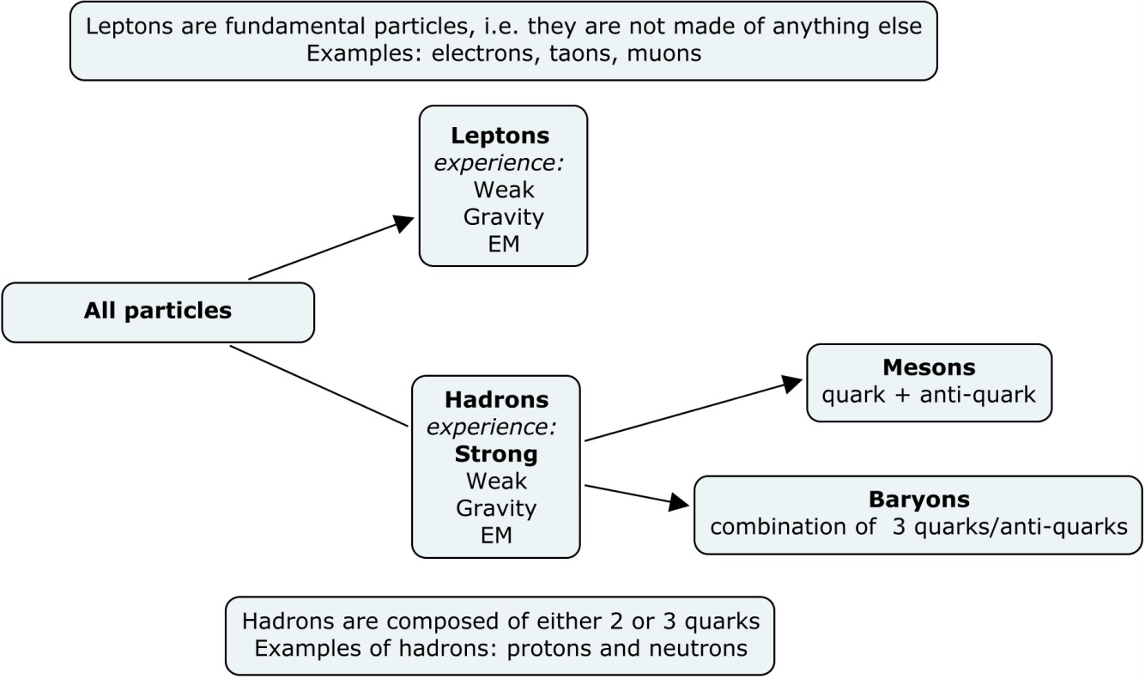

**Any time you want to refer to the gravitational force as part of an answer you must use exactly that term, i.e. you must say ‘*gravitational force’* and not ‘*gravity’*.**

**Similarly you should refer to the ‘*strong nuclear force’* rather than the ‘*strong force’*.**

*Does not science tell us that its highest striving is after the ascertainment of a unity which shall bind the smallest things with the greatest?*The Mill on the Floss, a novel by George Eliot (published in 1860, approximately 100 years before scientists figured this out).

Oh. And in case you were wondering, you really shouldn’t be here.

See greatideas.ie for more information on this.

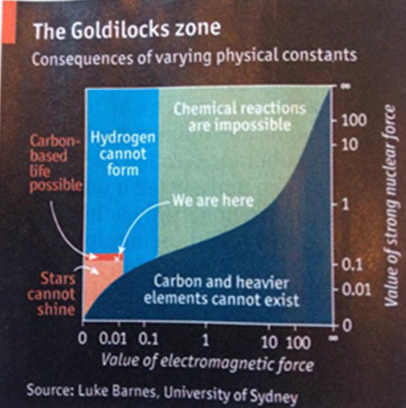

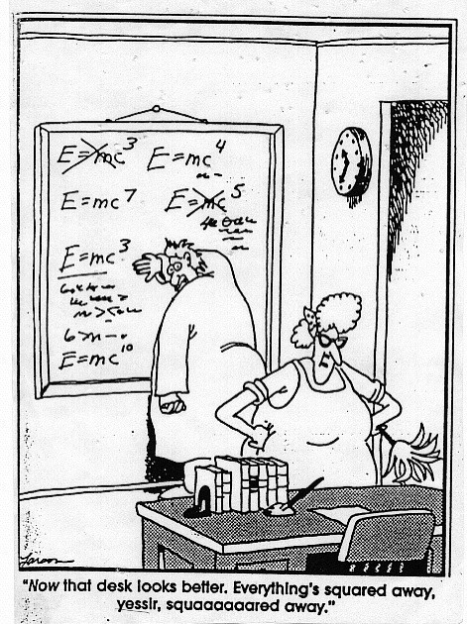

**Leaving Cert Physics Syllabus**

|  |  |  |  |
| --- | --- | --- | --- |
| **Content** | **Depth of Treatment** | **Activities** | **STS** |
|  |  |  |  |
| 1. Conservation of  energy and  momentum in  nuclear reactions | Radioactive decay resulting in two particles.  If momentum is not conserved, a third particle (neutrino) must be present. | Appropriate calculations to convey sizes and magnitudes and relations between units. |  |
|  |  |  |  |
| 2. Acceleration of  protons | Cockcroft and Walton –  Proton energy approximately 1 MeV: Outline of experiment. | Appropriate calculations. | First artificial splitting of nucleus.  First transmutation using artificially accelerated particles.  Irish Nobel laureate for physics, Professor E. T. S. Walton (1951). |
|  |  |  |  |
| 3. Converting mass  into other forms of  energy | “Splitting the nucleus”  H + Li → He + He + Q  1 MeV 17.3 MeV  Note energy gain.  Consistent with *E* = *mc* 2 |  |  |
|  |  |  |  |
| 4. Converting other  forms of energy  into mass | Reference to circular accelerators  progressively increasing energy  available:  proton-proton collisions  p + p + energy → p + p + additional particles. | Audiovisual resource material. | History of search for basic  building blocks of nature:  • Greeks: earth, fire, air, water  • 1936: p, n, e.  Particle accelerators, e.g. CERN. |
|  |  |  |  |
| 5. Fundamental forces of nature | Strong nuclear force:  Force binding nucleus, short range.  Weak nuclear force:  Force between particles that are not subject to the strong force, short range.  Electromagnetic force:  Force between charged particles, inverse square law.  Gravitational force: inverse square law. |  |  |
|  |  |  |  |
| 6. Families of  particles | Mass of particles comes from  energy of the reactions –  *m* = E/c2  The larger the energy the greater the variety of particles. These particles are called “particle zoo”.  Leptons: indivisible point objects, not subject to strong force, e.g. electron, positron, and neutrino.  Baryons: subject to all forces, e.g. protons, neutrons, and heavier particles.  Mesons: subject to all forces, mass between electron and proton. | Appropriate calculations. | Pioneering work to investigate the structure of matter and origin of universe.  International collaboration, e.g. CERN. |
|  |  |  |  |
| 7. Anti-matter | e+ positron, e– electron.  Each particle has its own anti-particle.  Pair production: two particles produced from energy.  γ rays → e+ + e– conserve charge, momentum.  Annihilation: Two γ rays from annihilation of particles.  e+ + e– → 2*hf* (γ rays) conserve charge, momentum. |  | Paul Dirac predicted anti-matter mathematically. |
|  |  |  |  |
| 8. Quark model | Quark: fundamental building block of baryons and mesons.  Six quarks – called up, down, strange, charmed, top, and bottom.  Charges: u+2/3 , d-1/3 , s-1/3  Anti-quark has opposite charge to quark and same mass.  Baryons composed of three quarks: p = uud, n = udd, other baryons any three quarks.  Mesons composed of any quark and an anti-quark. | Identify the nature and charge of a particle given a combination of quarks. | James Joyce: “Three quarks for Muster Mark”. |
|  |  |  |  |

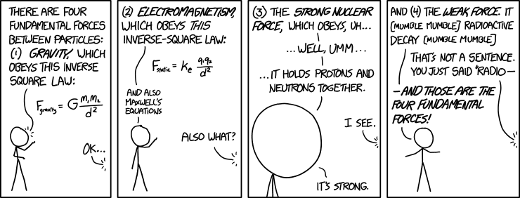

<http://xkcd.com/1489/>

**Extra Credit**

**Particle Physics – The Maths**

You must be comfortable using scientific notation (and brackets for complicated expressions) on your calculators.

**E = mc2**

Note that the Energy can be referred to as any of the following:

Loss in mass / Mass Defect / Missing Mass / Energy Released / Disintegration Energy.

**Joules ↔ Electronvolts**

Quite often I can’t remember whether I should multiply or divide by 1.6 x 10-19, so I have to remind myself that there are a lot of electron-volts in one Joule, so if I’m converting from eV to Joules, the number should get smaller, or conversely if I’m going from Joules to eV the number should get bigger.

**Kilograms ↔ Atomic Mass Units**

A similar reasoning applies to this conversion.

**\*Cockroft and Walton experiment as published in *Nature*: *Disintegration of Lithium by Swift Protons***

*On applying an accelerating potential of the order of 125 kilovolts, a number of bright scintillations were at once observed, the numbers increasing rapidly with voltage up to the highest voltages used, namely, 400 kilovolts. At this point many hundreds of scintillations per minute were observed using a proton current of a few microamperes. No scintillations were observed when the proton stream was cut off or when the lithium was shielded from it by a metal screen.*

*The brightness of the scintillations and the density of the tracks observed in the expansion chamber suggest that the particles are normal a-particles. If this point of view turns out to be correct, it seems not unlikely that the lithium isotope of mass 7 occasionally captures a proton and the resulting nucleus of mass 8 breaks into two a-particles, each of mass four and each with an energy of about eight million electron volts. The evolution of energy on this view is about sixteen million electron volts per disintegration, agreeing approximately with that to be expected from the decrease of atomic mass involved in such a disintegration.*

*Experiments are in progress to determine the effect on other elements when bombarded by a stream of swift protons and other particles.*

J. D. COCKCROFT.  
E. T. S. WALTON.

Published in *Nature, April 30, 1932*.

**\*The particle zoo**

Why this term? Because back when scientists were discovering these new particles, zoos weren’t organised like they are now. In fact they weren’t organised at all. Instead of having all animals who would normally live in the African plains together in one section of the zoo, each animal was housed in the next available room. So as a visitor you never knew what you were going to see next as you walked around.

A bit like one of these scientists analysing data from their colliders.

**\*Antimatter**

In Dan Brown’s *Angels and Demons*, 250 milligrams (one quarter of a gram) of antimatter is all that is required to destroy the Vatican; this would produce as much energy as 10,000 kilotons of TNT, about half the energy of the atomic bomb dropped on Hiroshima.

“*But it would cost a thousand, trillion US dollars, and somebody, somewhere would notice that kind of expense*”, according to David McGinnis, writing in the magazine *Symmetry*, published by Fermi lab and Stanford Linear Accelerator Center (SLAC).

*New Scientist*

**Beta decay** is what drives PET scanners. (Positron Emission Tomography). You give someone a dose of a chemical (usually Fluorine-18 - an example of a radioisotope) containing suitable short half-life beta+ emitter (emits positrons) and you can track very accurately where that chemical goes in the body, because the positron interacts with a nearby electron to give two very collimated gamma rays with equal energy travelling in opposite directions, which you can detect and extrapolate their path. You can apply momentum and mass/energy conservation to this process.

**\*Pair production**

As I understand it, the interaction of high energy photons with matter is predominantly ***photoelectric effect*** (emission of electrons from the surface of the metal) for photon energies up to about 0.1 MeV, ***compton scattering*** (causing recoil of the electron, similar to a collision between particles) up to about 3 MeV and ***pair production*** for higher energies.

**\*Conservation of momentum**

Okay, you’ve spotted that there’s something iffy about electromagnetic radiation having momentum; if momentum is defined as being the product of mass and velocity and if photons don’t have mass, then surely the momentum is zero?

But momentum ***can*** be applied to photons of electromagnetic radiation.

Strictly speaking, the total energy of anything whatsoever is given by E2=p2c2 + Mo2c4.

Where p = momentum, and M0 represents the mass of the particle at rest.

This gets reduced to E = mc2 for most applications.

However for a photon, its mass is zero, and therefore the equation in this case reduces to E = pc

Therefore for a photon which does have energy hf but no mass and therefore no rest energy, its momentum is given by p=E/c.

This means that the 'push' that photons give on e.g. a solar sail is due to their momentum which is not mv but E/c.

Still confusing? Okay, but do I not at least get some points for acknowledging that this is a source of confusion – many of the textbooks mention this in a blasé manner which suggests this is most obvious thing in the world.

What is this thing called ‘rest mass’?

Why do objects get more ‘massive’ when they travel at very fast speeds?

From the formula E = mc2

If you try to accelerate a proton, at first its velocity increases, but as its velocity increases so does its mass (from special relativity), and as a result it gets harder to accelerate it.

At a speed of 99.997 the speed of light the mass of the proton is 430 times its ‘rest mass’.

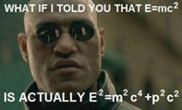This is why running particle accelerators is usually done at night; the amount of electricity would actually be enough to power a small town.

**Still not convinced that electromagnetic radiation has momentum?  
Consider the following:**

Shine a light at a stationary toy car that’s powered by light via a solar panel.

The car starts moving?

Where did the momentum come from?

Got it in one.

I should have been a teacher . . .

**\*Why do we need the neutron?**

The disappearance of a photon followed by the appearance of an electron and positron (without any neutron) cannot conserve both total energy and momentum.

To ensure that momentum as well as energy is conserved, you need something nearby to participate and absorb the recoil.

So there you go.

Question: Did you know that photons have mass?

Answer: I didn’t even know they were catholic!

**\*The Lepton**

The name *lepton* derives from Greek word *leptos* meaning “light, not heavy”.

It was originally assigned to electron and neutrino.

**\*Murray Gell-Mann**

He wrote that Physics at high school was “the dullest course I had ever taken”, and he only applied to study physics at university “to please my father”.

Taken from; *When we were kids: how a child becomes a scientist*.

I wonder how his physics teacher felt when he read that?

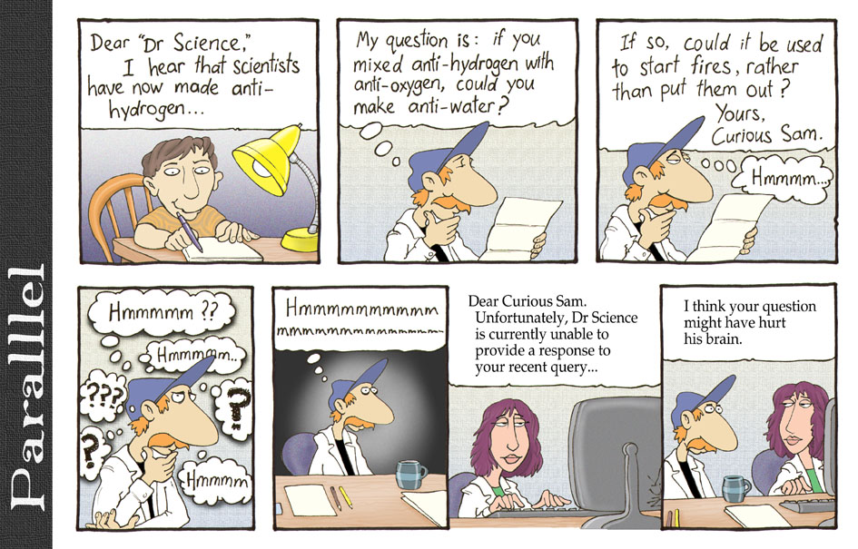\***The Neutrino**

We have seen that in Beta Decay, a neutron breaks up in to a proton and an electron.

The equation is n0 → p+ + e-

However when scientists investigated the momentum before and after, they noticed something strange.

The momentum after was a little less than the momentum beforehand, and no matter how many times they repeated the experiment they got the same result.

It was as if there was something missing on the right hand side, but they couldn’t find anything. It was all very confusing.

*Picture the situation:*

A certain amount of energy and momentum go into the equation, but not enough comes out.

Up steps a well-known Italian scientist called Wolfgang Pauli to suggest that there actually is more momentum coming out, but the reason that it is not detected is because it comes in the form of particles which have no charge, and whose mass is too small to be detected.

It’s kinda hard to be proved wrong in that one!

Pauli coined the name ‘neutrino’ for the particle because it means ‘little neutral one’ in Italian.

By the way, this is indeed the same Pauli of ‘Pauli’s Exclusion Principle’ fame, which those of you sad enough to be doing Chemistry will recognise.

To give an idea of how radical a prediction this is, remember that all good science is supposed to be built upon the cornerstone of experiments.

If you predict something to exist but that it can never be verified by experiment then you may as well be talking about the existence of God; It’s not to say that God doesn’t exist, it’s just that in science we have to stick to what we can verify by experiment.

Then along comes Pauli and breaks this golden rule.

In fairness, Pauli realised this himself. He admitted, “*I have done a terrible thing – I have predicted the existence of a particle which cannot be detected”!*

But these were strange times in physics; Ernest Rutherford was probably the foremost physicist alive at this stage (he had, after all, split the atom. Cockroft and Walton were working under Rutherford when they carried out their groundbreaking experiment).

Rutherford’s advice was to assume that the Conservation of Energy law probably didn’t apply at this level.

As it turned out, the neutrino was detected experimentally in 1956, although there is still much that remains unknown about this particle.

For instance did you know that somewhere between 90% and 99% of all matter in this universe is unaccounted for?

One possible explanation is that the neutrino is carrying this mass.

While it is obviously very, very, *very* light, the small mass it does have, multiplied by the sheer (literally?) weight of numbers, may make it the culprit.

Did you know there are 10 x 1014 neutrinos pass through you every second, coming from the sun?

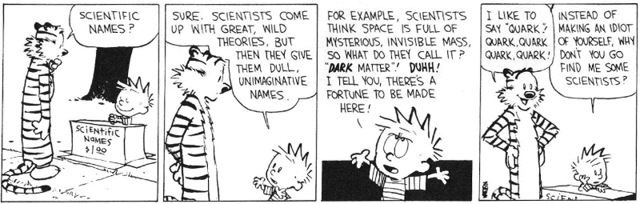The fact that at night-time the Earth is between you and the Sun doesn’t matter – these little critters pass straight through the Earth!

**Cosmic Gall**

Neutrinos, they are very small.

They have no charge and have no mass

And do not interact at all.

The earth is just a silly ball

To them, through which they simply pass,

Like dustmaids down a draughty hall

Or photons through a sheet of glass.

They snub the most exquisite gas,

Ignore the most substantial wall,

Cold shoulder steel and sounding brass,

Insult the stallion in his stall,

And scorning barriers of class,

Infiltrate you and me! Like tall

And painless guillotines, they fall

Down through our heads into the grass.

At night they inter at Nepal

And pierce the lover and his lass

From underneath the bed – you call

It wonderful; I call it crass.

*Telephone Poles and Other Poems*, John Updike, Knopf, 1960

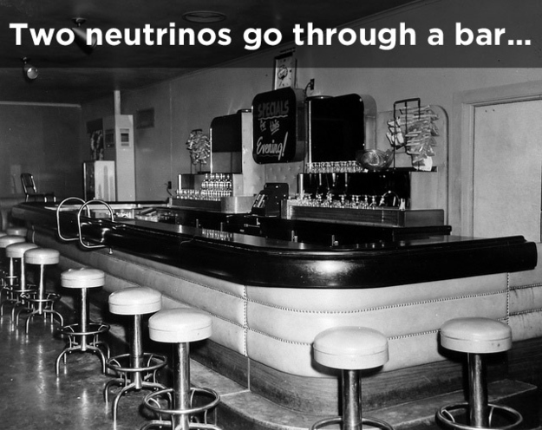

**CERN announces discovery of new element: Governmentium**

Researchers at CERN have this morning announced the discovery of the heaviest element yet known to science. The new element, Governmentium (symbol=Gv), has one neutron, 25 assistant neutrons, 88 deputy neutrons and 198 assistant deputy neutrons, giving it an atomic mass of 312.  
   
These 312 particles are held together by forces called morons, which are surrounded by vast quantities of lepton-like particles called pillocks. Since Governmentium has no electrons, it is inert. However, it can be detected, because it impedes every reaction with which it comes into contact.  
   
A tiny amount of Governmentium can cause a reaction that would normally take less than a second, to take from 4 days to 4 years to complete. Governmentium has a normal half-life of 2 to 6 years. It does not decay, but instead undergoes a reorganization in which a portion of the assistant neutrons and deputy neutrons exchange places.  
   
In fact, Governmentium’s mass will actually increase over time, since each reorganization will cause more morons to become neutrons, forming isodopes. This characteristic of moron promotion leads some scientists to believe that Governmentium is formed whenever morons reach a critical concentration. This hypothetical quantity is referred to as a critical morass. When catalysed with money, Governmentium becomes Administratium (symbol=Ad), an element that radiates just as much energy as Governmentium, since it has half as many pillocks but twice as many morons.

“Figuring out what happened in a collider is like trying to figure out what your dog ate at the park yesterday. You can find out, but you have to sort through a lot of sh*t to do it.”  
MIT physicist Jesse Thaler

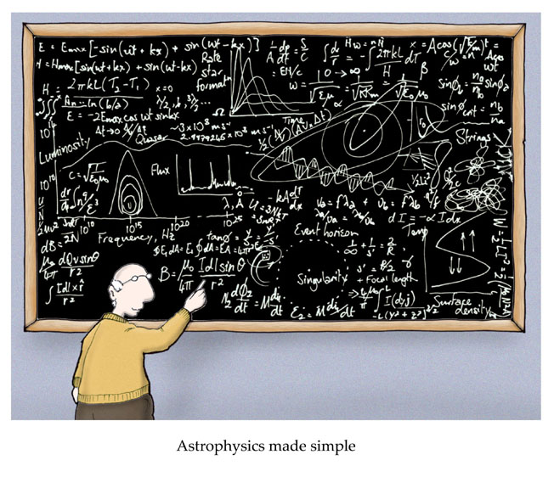

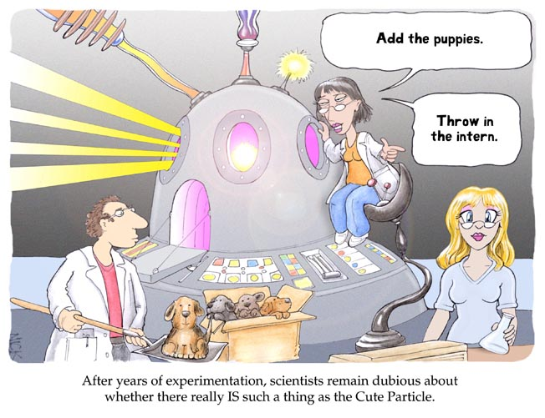

**Exam Questions**

mass of proton = 1.6730 × 10-27 kg; mass of electron = 9.1 × 10–31 kg;

mass of lithium nucleus = 1.1646 × 10-26 kg; mass of α-particle = 6.6443 × 10-27 kg;

mass of neutron = 1.6749 × 10–27 kg; charge on electron = 1.6022 × 10–19 C;

mass of pion = 2.4842 × 10–28 kg;

speed of light, c = 2.9979 × 108 ms-1; Planck constant = 6.626 × 10-34 J s

**Particle Accelerators, Cockroft and Walton Experiment and E = mc2**

1. [2009]

In 1932 Cockcroft and Walton succeeded in splitting lithium nuclei by bombarding them with artificially accelerated protons using a linear accelerator.

Each time a lithium nucleus was split a pair of alpha particles was produced.

1. How were the protons accelerated?
2. How were the alpha particles detected?
3. [2005]

High voltages can be used to accelerate alpha particles and protons but not neutrons.

Explain why.

1. [2009]

Most of the accelerated protons did not split a lithium nucleus. Explain why.

1. [2002]

In 1932, Cockcroft and Walton carried out an experiment in which they used high-energy protons to split a lithium nucleus. Outline this experiment.

1. [2007]

Draw a labelled diagram to show how Cockcroft and Walton accelerated the protons.

1. [2009] [2007] [2005][2002]

Write a nuclear equation to represent the splitting of a lithium nucleus by a proton.

1. [2005][2009][2010]

Circular particle accelerators were later developed.

Give two advantages of circular accelerators over linear accelerators.

1. [2004]

In beta decay, a neutron decays into a proton with the emission of an electron.

Write a nuclear equation for this decay.

**The neutrino**

1. [2008]

The existence of the neutrino was proposed in 1930 but it was not detected until 1956.

Give two reasons why it is difficult to detect a neutrino.

1. [2007]

In beta decay it appeared that momentum was not conserved.

How did Fermi’s theory of radioactive decay resolve this?

1. [2004]

Momentum and energy do not appear to be conserved in beta decay.

Explain how the existence of the neutrino, which was first named by Enrico Fermi, resolved this.

**Antimatter**

1. [2010] What is anti-matter?
2. [2010]  
   An anti-matter particle was first discovered during the study of cosmic rays in 1932.

Name the anti-particle and give its symbol.

1. [2007] Compare the properties of an electron with that of a positron.
2. [2007] What happens when an electron meets a positron?
3. [2003] Give one contribution made to Physics by Paul Dirac.
4. [2005]

In an accelerator, two high-speed protons collide and a series of new particles are produced, in addition to the two original protons. Explain why new particles are produced.

**Pair Production**

1. [2010]What is meant by pair production?
2. [2010]  
   A photon of frequency 3.6 × 1020 Hz causes pair production.

Calculate the kinetic energy of one of the particles produced, each of which has a rest mass of 9.1 × 10–31 kg.

**Pair Annihilation**

1. [2010] What happens when a particle meets its anti-particle?
2. [2006]

During a nuclear interaction an antiproton collides with a proton.

Pair annihilation takes place and two gamma ray photons of the same frequency are produced.

1. What is a photon?
2. Calculate the frequency of a photon produced during the interaction.
3. Why are two photons produced?
4. Describe the motion of the photons after the interaction.
5. How is charge conserved during this interaction?
6. After the annihilation, pairs of negative and positive pions are produced. Explain why.
7. [2003]
8. Write a reaction that represents pair annihilation.
9. Explain how the principle of conservation of charge and the principle of conservation of momentum apply in pair annihilation.

**Fundamental Forces**

1. [2008]

Baryons and mesons are made up of quarks and experience the four fundamental forces of nature.

List the four fundamental forces and state the range of each one.

1. [2006] List the fundamental forces of nature that pions experience.
2. [2002][2005] Name the fundamental force of nature that holds the nucleus together.
3. [2004]

Beta decay is associated with the weak nuclear force.

List two other fundamental forces of nature and give one property of each force.

1. [2002] Name the four fundamental forces of nature.
2. [2009] Arrange the fundamental forces of nature in increasing order of strength.
3. [2002] Give two properties of the strong force.

**Quark Composition and Particle Classification**

1. [2010] What famous Irish writer first thought up the name ‘quark’?
2. [2008] Name the three positively charged quarks.
3. [2008] What is the difference in the quark composition of a baryon and a meson?
4. [2008] [2005] What is the quark composition of the proton?
5. [2007] A kaon consists of a strange quark and an up anti-quark. What type of hadron is a kaon?
6. [2006]

Pions are mesons that consist of up and down quarks and their antiquarks.

Give the quark composition of (i) a positive pion, (ii) a negative pion.

1. [2006]

Name the three negatively charged leptons. {As I understand it this isn’t on the syllabus and shouldn’t have been asked}.

1. [2004] Give the quark composition of the neutron.
2. [2005]

A huge collection of new particles was produced using circular accelerators. The quark model was proposed to put order on the new particles. List the six flavours of quark.

1. [2003]

Leptons, baryons and mesons belong to the “particle zoo”.

Give (i) an example, (ii) a property, of each of these particles.

1. [2010]  
   A member of a meson family consists of two particles. Each particle is composed of up and down quarks and their anti-particles.

Construct the possible combinations. Deduce the charge of each combination and identify each combination.

**Exam Solutions**

1. They were accelerated by the very large potential difference which existed between the top and the bottom
2. They collide with a zinc sulphide screen, where they cause a flash and get detected by microscopes.
3. Alpha particles and protons are charged, neutrons are not.
4. The atom is mostly empty space so the protons passed straight through.

* Protons are produced and released at the top of the accelerator.
* The protons get accelerated across a potential difference of 800 kVolt.
* The protons collide with a lithium nucleus at the bottom, and as a result two alpha particles are produced.
* The alpha particles move off in opposite directions at high speed.
* They then collide with a zinc sulphide screen, where they cause a flash and get detected by microscopes.

1. See diagram in notes
2.  +  →  + K.E.
3. Circular accelerators result in progressively increasing levels of speed/energy and occupy much less space than an equivalent linear accelerator.
4. 
5. No charge and very small mass.
6. Fermi (and Pauli) realised that another particle must be responsible for the missing momentum, which they called the neutrino.
7. Momentum and energy are conserved when the momentum and energy of the (associated) neutrino are taken into account.
8. Antimatter is material/matter/particles that has same mass as another particle but opposite charge.
9. positron / anti-electron
10. Both have equal mass / charges equal / charges opposite (in sign) / matter and anti-matter
11. Pair annihilation occurs.
12. Dirac predicted antimatter.
13. The kinetic energy of the two protons gets converted into mass.
14. Pair production involves the production of a particle and its antiparticle from a gamma ray photon.
15. Energy associated with the photon = hf;

E = (6.6 × 10-34)( 3.6 × 1020) = 2.376 × 10-13 J

Energy required to produce the two particles = 2[mc2]

E = 2(9.1 × 10-31)(3.0 × 108)2 = 1.638 × 10-13 J

Extra energy available for kinetic energy = (2.376 × 10-13) – (1.638 × 10-13) = 7.38 × 10-14

Kinetic energy per particle is half of this = 3.69 × 10-14 J

1. Pair annihilation occurs and the mass gets converted to energy.
2. A photon is a discrete amount of electromagnetic radiation.
3. m [= mass of proton + mass of antiproton ] = 2(1.673 × 10-27) = 3.346 × 10-27 kg

E = mc2 = (3.346 × 10-27 )(2.998 × 108)2 = 3.0074 × 10-10

Energy for one photon = 1.5037 × 10-10 J

E = hf  f = E/h / = 1.5037 × 10-10 / 6.626 × 10-34 = 2.2694 × 1023 Hz

1. So that momentum is conserved.
2. They move in opposite directions.
3. Total charge before = +1-1 = 0

Total charge after = 0 since photons have zero charge

1. The energy of the photons is converted into matter.
2. e+ + e- → 2γ
3. Total charge on both sides is zero

Momentum of positron + electron = momentum of photons

1. Strong (short range), Weak (short range), Gravitational (infinite range), Electromagnetic (infinite range).
2. Electromagnetic, strong, weak , gravitational
3. The strong nuclear force.
4. Strong: acts on nucleus/protons + neutrons/hadrons/baryons/mesons, short range

Gravitational: attractive force, inverse square law/infinite range, all particles

Electromagnetic: acts on charged particles, inverse square law/infinite range

1. Gravitational, Electromagnetic, Strong (nuclear), Weak (nuclear)
2. Gravitational, weak, electromagnetic, strong.
3. Short range, strong(est), act on nucleons, binds nucleus
4. (James) Joyce
5. Up, top, charm
6. Baryon: three quarks

Meson: one quark and one antiquark

1. Up, up, down
2. It is a meson.
3. π+ = up and anti-down

π- = down and anti-up

1. Electron (*e*) , muon (*μ*), tau (*τ* )
2. Up, down, down
3. Up, down, strange, charm, top and bottom.
4. LEPTONS; electron, positron, muon , tau, neutrino

Not subject to strong force

BARYONS; proton, neutron

Subject to all forces, three quarks

MESONS pi(on), kaon

Subject to all forces, mass between electron and proton, quark and antiquark

|  |  |  |  |
| --- | --- | --- | --- |
| composition | | charge | name |
| u + |  | 0 | Pi-neutrino |
| u + |  | +1 | Pi-plus |
| d + |  | -1 | Pi-minus |
| d + |  | 0 | Pi-neutrino |

**Particle Physics: Maths Questions**

Maths questions in this topic are all about energy conversions

The energy can take one of four forms.

1. It can be *potential energy*: **W = QV**

(Q is charge, V is potential difference)

Example: Linear accelerators

1. It can be *kinetic energy*: **E = ½ mv2**  
   (m is mass, v is velocity)

Example: Proton-proton collisions

1. It can be in the form of *electromagnetic radiation* where **E = hf**   
   (f is frequency, h is Planck’s constant)

Example: Pair production

1. It can be in the form of *mass*, in which case the energy equivalent is **E = mc2**

(m is mass, c is the speed of light)

Example: Large Hadron Collider, Pair annihilation

The context will determine which of the above equations you will need

**Notes**

1. Make sure you can convert from electron-Volts (eV) to Joules (J) and vice-versa

(1eV =1.6 x 10–19 Joules)

1. Be comfortable dealing with very large numbers and very small numbers on your calculator.
2. Be comfortable using the log-table to find all relevant information, particularly the mass of the particles.  
   In particular note that page 47 and page 83 are the most used pages.  
   Note also that on page 83, masses of nuclei are given in terms of the atomic mass unit (u). You then need to go to page 47 to find the mass of one atomic mass unit.

**Energy conversions**

**Linear Accelerator**

***potential energy* → *kinetic energy  
QV → ½ mv2***

**Cockroft and Walton experiment**

Some of the mass beforehand disappears and is converted into kinetic energy of the new particles

***mass → kinetic energy***

** +  →  + K.E.**

**mc2 → K.E**

**Proton-Proton Collisions**

The kinetic energy of the protons just before the collision is converted into the mass of the new particles which were created just after the collision

***kinetic energy → mass***

***+ + kinetic energy = + + additional particles***

**{+ *K.E. of the newly created particles*}**

**K.E → mc2 {+ K.E.}**

**Pair Production**

Energy in the form of electromagnetic radiation (associated with gamma radiation) is converted into mass.

***→ e- + e+ {+ K.E. of the newly created particles}***

**hf → 2c2**

**Pair Annihilation**

Mass is converted into energy in the form of electromagnetic radiation.

**2c2 → 2hf**

**Linear Accelerator**

1. [2007]

What is the velocity of a proton when it is accelerated from rest through a potential difference of 700 kV?

AND

[2013]   
Calculate the speed of a proton that has a kinetic energy of 700 keV.

1. [2004]  
   Calculate the energy released during the decay of a neutron.

**Cockroft and Walton experiment**

1. [2002][2007][2009]

When a lithium nucleus () is bombarded with a high-energy proton, two α-particles are produced.

Calculate the energy released in this reaction.

**Proton-Proton Collisions**

1. [2009]  
   In the Large Hadron Collider, two beams of protons are accelerated to high energies in a circular accelerator.   
   The two beams of protons then collide producing new particles. Each proton in the beams has a kinetic energy of 2.0 GeV.   
   What is the maximum net mass of the new particles created per collision?
2. [2011]  
   In the Large Hadron Collider, two protons with the same energy and travelling in opposite directions collide.   
   Two protons and two charged pi mesons are produced in the collision.
3. Write an equation to represent the collision.
4. Show that the kinetic energy of each incident proton must be at least 140 MeV for the collision to occur.
5. [2008]  
   In a circular accelerator, two protons, each with a kinetic energy of 1 GeV, travelling in opposite directions, collide. After the collision two protons and three pions are emitted.
6. What is the net charge of the three pions? Justify your answer.
7. Calculate the combined kinetic energy of the particles after the collision
8. Calculate the maximum number of pions that could have been created during the collision.

**Pair production**

1. [2003]  
   The following reaction represents pair production: γ → e+ + e–
2. Calculate the minimum frequency of the γ-ray photon required for this reaction to occur.
3. What is the effect on the products of a pair production reaction if the frequency of the γ-ray photon exceeds the minimum value?

**Pair Annihilation**

1. [2014]
   1. Write an equation to represent pair annihilation.
   2. Calculate the frequency of each photon produced in this pair annihilation.
   3. Why do the photons produced in pair annihilation travel in opposite directions?
2. [2006]

During a nuclear interaction an antiproton collides with a proton.

Pair annihilation takes place and two gamma ray photons of the same frequency are produced.

1. What is a photon?
2. Calculate the frequency of a photon produced during the interaction.
3. Why are two photons produced?
4. Describe the motion of the photons after the interaction.
5. How is charge conserved during this interaction?
6. After the annihilation, pairs of negative and positive pions are produced. Explain why.

**Linear Accelerator**

* + 1. What is the velocity of a proton when it is accelerated from rest through a potential difference of 700 kV?   
       P.E. = K.E.   
       qV = ½ mv2   
       v2 = 2qV/m   
       v2 = 2(1.6022 × 10-19)(7.00 × 105)/ 1.6726 × 10-27  
       v = 1.16 × 107 m s-1
    2. Calculate the energy released during the decay of a neutron.  
       Mass lost = mass before – mass after = (mass of neutron) – [(mass of proton + electron)]

= (1.6749 × 10–27) – [(1.6726 × 10–27 + 9.1094 × 10–31)]

= 1.3891 × 10-30 kg

E = mc2 = (1.3891 × 10-30)(2.9979 × 108)2 = 1.25 × 10-13 J

1. Write a nuclear equation to represent the splitting of a lithium nucleus by a proton.  
   Calculate the energy released in this reaction.

Loss in mass:  
Mass before = mass of proton (1.6726 × 10–27) + mass of lithium nucleus (1.1646 × 10–26) = 1.33186 × 10-26 kg  
Mass after = mass of two alpha particles = 2 × (6.6447 × 10–27) = 1.32894 × 10-26 kg  
Loss in mass = 1.33186 × 10-26 - 1.32894 × 10-26 = 2.92 × 10-29 kg

E = mc2 = (2.92 × 10-29) (2.9979 × 108)2 = 2.6 × 10-12 J

1. When the protons collide into each other they lose their kinetic energy and it is this energy which gets converted into mass to form the new particles.
2. Total energy = 4 GeV   
   E = mc2

⇒ m = E/ c2   
⇒ m = (4 × 109) (1.6 × 10-19)/(2.9979 × 108)2  
⇒ m = 7.121 × 10-27 kg

5.

1. Write an equation to represent the collision.

p + p p + p + + + π-

1. Show that the kinetic energy of each incident proton must be at least 140 MeV for the collision to occur.  
   Mass of π+ = 273 me = 273(9.109×10-31) kg  
   E = 2mec2  
   E = 2(2.4869×10-28)(3×108)2 = 44.76 ×10-12 J

E = 279.94 ×106 eV 280 MeV

This is the total kinetic energy that must be available to produce the two pions so the energy each proton has must be greater than 140 MeV.

6.

1. Zero, because electric charge must be conserved.
2. Energy equivalent of a pion:)

E = mc2  
E = (2.4842 )( 2.9979 × 108)2  
E = 2.2327 × 10–11 J = 1.3935 × 108 eV  
For 3 pions E = 6.6980 × 10–11 J = 4.18047 × 108eV  
Energy after collision = (2 × 109) - (4.18047 × 108) = 1.58195 × 109 eV = 2.535 × 10–10 J

1. Number of pions = (1.58195 × 109) / 1.3935 × 108 = 11.3524 = 11 pions.  
   Maximum number of pions = 3 + 11 = 14 pions.
2. E = (2)mc2 = hf

2(9.1 × 10–31)( 3.0 × 108)2 = (6.6 × 10–34)f

⇒ f = 2.5×1020 Hz

1. The electrons which were created would move off with greater speed.

There may also be more particles produced.

1. e− + e+ → 2hf
2. hf = mc2f **=** 1.2356 × 1020 Hz
3. momentum is conserved
4. A photon is a discrete amount of electromagnetic radiation.
5. m [= mass of proton + mass of antiproton ] = 2(1.673 × 10-27) = 3.346 × 10-27 kg E = mc2 = (3.346 × 10-27 )(2.998 × 108)2 = 3.0074 × 10-10Energy for one photon = 1.5037 × 10-10 JE = hf  f = E/h / = 1.5037 × 10-10 / 6.626 × 10-34 = 2.2694 × 1023 Hz
6. So that momentum is conserved.
7. They move in opposite directions.
8. Total charge before = +1-1 = 0   
   Total charge after = 0 since photons have zero charge
9. The energy of the photons is converted into matter .

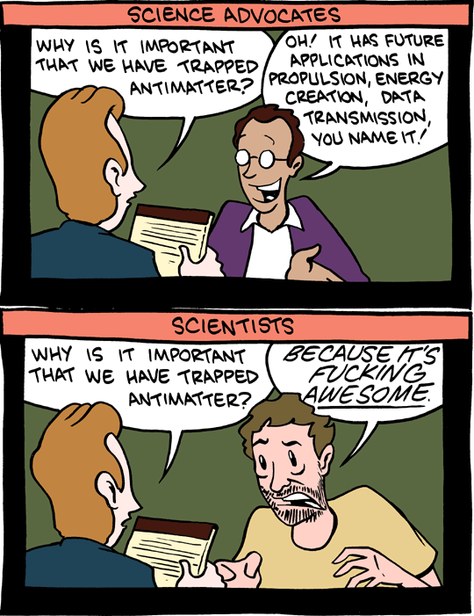

<http://smbc-comics.com/index.php?db=comics&id=2088#comic>

Not a bad note on which to end your Leaving Cert Physics course – I do hope you enjoyed the ride . . .